|  |  |
| --- | --- |
| **28/10/2011** | **Managing your files and folders (on your home computer or memory stick)** |

### File

Each letter, photograph, document, video and spread-sheet that is created electronically (on some kind of computer – it could be a digital camera or a mobile phone) is stored as a file.

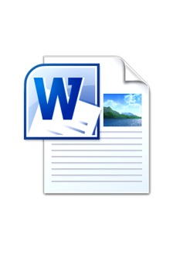  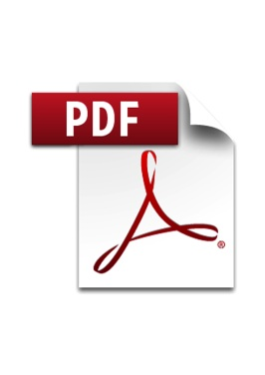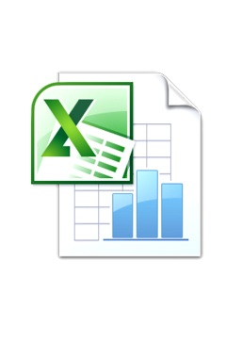

**File name**

Every file saved has a file name. You can decide on this – the best file name is the one that means something to you. After the file name there will be a file extension (of three or four letters) for the application that is used to show it. e.g. Microsoft Word is the application that is used for word processing and has the extension .doc or .docx.

You can use lots of words for the filename (up to 256 letters and spaces but do NOT use special characters, \ / : * ? " < > | as those will not be allowed and you will have to type it again!)

### File extension

Normally you do not see the file extension (it makes it simpler) but every file has a “file type” and that is shown with the extension. Some examples are:

*  **Filename.doc** is a Word file (stands for document)
* **Filename.jpg** is a photo file (it should be jpeg and stands for “Joint Photographics Experts Group”)

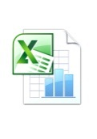

* 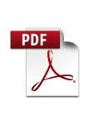 **Filename.xls** is an Excel file (a spreadsheet)
* **Filename.pdf** is a file that looks like a printed document and you cannot change it (stands for portable document format)
* **Filename.wma** is a music file (Windows Media Audio)
* **Filename.avi** is a video file (Audio Video Interleave)

### Folder

You can place your files in a folder and you can make as many folders and subfolders (folders within a folder) as you need. Think of a computer as being a big filing cabinet with hanging folders in each pull-out drawer.

The hanging folders could have labelled card folders inside to help find the sheets of paper (letters or documents) and photographs inside.

**Disk drive**

The physical location where folders and files can be found. A disk drive name consists of a single letter and a colon.  
Drive A: = used to be the floppy (3.5 inch) disk drive and have been phased out since 2005  
Drive C: = Is always the first hard disk drive  
Drive D to Z: = optional drives and “Devices with Removable Storage” (a second hard drive, CD-ROM or DVD drive, memory stick, memory card etc.)

Open the “My Computer” window (XP) or “Computer” window (Vista or Windows 7), for a list of the drives (you can find it in the Start Menu).

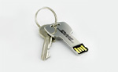Think of your memory stick as a smaller filing cabinet that you can miraculously carry around with you. This is a picture of one shaped like a key!

It is worth remembering that laptops in 2000 came with 6G (Giga bytes or 1,000 million bytes) of storage and you can now buy memory sticks with 8G for only a few pounds! 2G is enough for 400 quite large photo files (5 MB - Mega bytes or 5 million bytes of information per image).

### Path name

The complete name of your file on a computer actually includes the *path* name. A path describes where a file is located on your computer.

The path name lists the drive (such as the hard disk, or memory stick/memory card or CD-ROM/DVD) and folder that contains your data file.

When you use the Recycle Bin or Find/Search feature, you will see the path name listed for each file.

Complete path and file name examples:  
C:\My Documents\Letter to James.docx  
E:\LUCY MSTICK\Reminiscence garden.jpg

Think of the equivalent in a filing cabinet!

**Viewing files and folders**

Windows XP and Windows 7 show files and folders in slightly different ways. The best way to see is to try, go to My Computer or Computer (in the Start Menu) and test out the different views to find the one you like best.

In Windows XP click on the View menu in the Menu Bar and try out the different views. In Windows Vista/7 click the icon  in the top right and try them out to decide which one suits you.

The “Details” view is very useful as not only do you see lots of useful information about your files and folders but you can also sort them by clicking on the column headings.

In Windows 7 the “Computer” or the “Documents” window has two panes: the "Folders" pane, on the left, showing you all connected drives (under My Computer) and the "Contents" pane, on the right, showing the contents of the selected drive or folder.

To expand the view of a drive or folder in the "Folders" pane, click on the + symbol next to it or press the right arrow key, and you will see more detail in the hierarchical view. To see the contents of a folder, click once on the name or folder icon.

**Managing Files and Folders**

**To create a new folder on a memory stick:**

1. Select the location for the folder. For example, select the "LUCY MSTICK" .
2. Choose File > New > Folder from the menu bar in Windows XP or click on “New folder” in the standard buttons tool bar in Windows Vista/7. Or, right-click on a blank area of the Contents pane and choose New > Folder from the Shortcut menu.
3. Type in a folder name and press the <Enter> key.

You can move or copy files by using the Cut/Copy/Paste procedure

TIP: There are two ways to select multiple files or folders.

* To select consecutive files or folders, click the first item, press and hold down the <Shift> key, and then click the last item or arrow key to the last item.
* To select files or folders that are not consecutive, click the first item, press and hold down the <Ctrl> key, and then click each additional item or use your arrow keys to move to the file and the space bar key to select. N.B. Using the keyboard is safer as a slight move of the mouse with files selected will copy them all!

**To move files or folders:**

1. Select the file(s) or folder(s) to move.
2. Choose Edit > Cut in Windows XP or Organize> Cut in Windows Vista/7 (or right-click on a file or a folder to move and choose Cut from the Shortcut menu).
3. Select the destination folder.
4. Choose Edit > Paste in Windows XP or Organize> Paste in Windows Vista/7 (or right-click on the destination folder and choose Paste from the Shortcut menu).

### To copy files or folders:

1. Select the file(s) or folder(s) to copy.
2. Choose Edit > Copy (or click on the Copy button on the Toolbar or right-click on a file or a folder to copy and choose Copy from the Shortcut menu).
3. Select the destination location (for example, a different disk drive).
4. Choose Edit > Paste (or click on the Paste button on the Toolbar or right-click on the destination folder and choose Paste from the Shortcut menu).

### To rename a file or folder:

1. Select the file or folder to rename.
2. Choose File > Rename in Windows XP or, Organize> Rename in Windows Vista/7 from the menu bar (or right-click on the file or folder name and choose Rename from the Shortcut menu).
3. Type the new file or folder name in the text box.
4. Press <Enter> key.

### To delete a file(s) or folder(s):

1. Select the file(s) or folder(s) to be deleted.
2. Press <Delete> key (or right-click on the file or folder to be deleted and choose Delete from the Shortcut menu).
3. Click **Yes** in the Confirm File Delete dialog box to put the file in the Recycle Bin.

TIP: Deleting a folder also deletes all files in that folder.

## Using the Recycle Bin

The **Recycle Bin** acts as a temporary storage area for files deleted from your local hard drive. The Recycle Bin does NOT keep a copy of any file or folder deleted from other locations (memory stick).

Deleting a file or folder to the Recycle Bin does not delete the file from your local hard drive – it simply moves it to the Recycle Bin. The Recycle Bin allows you to restore deleted files. To permanently delete the file and regain some hard drive space, you need to delete the file(s) from the Recycle Bin.

### To restore deleted file(s) from the Recycle Bin:

1. Open the Recycle Bin outside of Windows Explorer by double-clicking on its icon on the Desktop.
2. Select the file(s) to be restored.
3. Choose File > Restore from the menu bar (or right-click on the file or folder to be restored and choose Restore from the Shortcut menu).

### To delete a file(s) from the Recycle Bin:

1. Select the Recycle Bin icon inside Windows Explorer or open the Recycle Bin on your desktop.
2. Select the file(s) to be deleted. NOTE: The column headings in the Recycle Bin are active buttons, so you can sort the files to list the way it is easiest for you to work with them.
3. Press <Delete> key (or right-click on the file or folder to be deleted and choose Delete from the Shortcut menu).
4. Click **Yes** in the *Confirm File Delete* dialog box.

To delete all files at one time from the Recycle Bin, use the *Empty Recycle Bin* option:

Choose File > Empty Recycle Bin then click **Yes** in the *Confirm Multiple File Delete* dialog box.