- I will sign in and out on the sheets provided, every time I use a computer in the Centre.
It is important and helpful if you could remember to sign in and out each time you use a computer, even when using it for a few minutes.

- I will be considerate to other members.
Log off when you have finished. Stop using the computer if, after a maximum of an hour, others are waiting. Remember to tidy up after yourself.

- I will help the atmosphere to be friendly and informal.
Members should expect to be friendly and informal towards each other in the Centre and are encouraged to share their skills and knowledge when difficulties arise.

- I will be as quiet as possible if I am in the Centre during another member’s one-to-one lesson.
The Computer Sharing Centre allows members uninterrupted access to a computer from 7.30am to 9.30pm on the understanding that lessons, (which can be noisy) are not disturbed.

- I will pay the charge of 5p for each page printed on the black and white printer. (Please put money in the tin provided).
The A3 colour printer is used only during the one-to-one lessons.

- I will wear the headsets connected to each computer monitor.
When listening to a pre-recorded radio or television program, or playing games in the Centre.

- I will not eat or drink in the Centre.
Drinks should be left outside.
Please note that only members and visitors (with Temporary membership) can use the computers. All residents and staff can become members by attending the £5 half hour induction. The Computer Sharing Centre is not like a library, it is more informal and quiet conversation is encouraged.

I understand the following
- The internet offers a wealth of information that is personally, professionally and culturally rewarding, it also enables access to some materials that may be controversial, disturbing, harmful, illegal or offensive (we use the OpenDNS filter that blocks explicit content). The Computer Sharing Centre takes no responsibility for the results of browsing the internet. The information that is accessed over the internet may not be accurate, complete, current, or unbiased.
- The Computer Sharing Centre offers the TopsitesTM homepage which has well known and respectable web sites that can be linked to easily.
- The “Like to Know” service allows residents and members to request reliable information from trained “Support Experts” who know how to get trustworthy results.
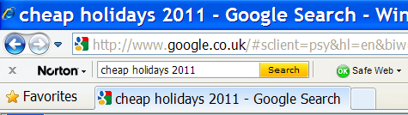
- Members are responsible for any financial transactions made while using the Centre’s internet connection.

When on the shopping site, check that the Norton Safe Web circle is green

When about to pay you should be able to see the secure “s” in the web site address e.g. https://amazon.co.uk. Also there will be a padlock here:

When using Google to search for a particular web site, check for the green O.K.

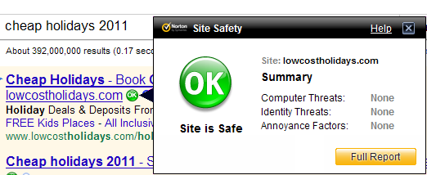
- Any misuse of a computer or poor conduct in the Centre may result in loss of membership.

