To Log on:
- If the black flashing cursor is not in the white rectangle beneath “Member x” (it normally is) -
- press the Tab 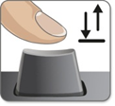 key until you can see the cursor next to the ‘P’ in Password - or click once in the white rectangle with your mouse.
Member 1

lPassword

- Type your member password carefully (the hint is “greeting” + the number on your computer - here we have number 1) - as you type, black dots will appear for each key press and there should be six!
●●●●●●l
Member 1

When you have finished typing press the Enter key or click on the blue circle with the arrow on the right.

You will now be logged on to the Member account!

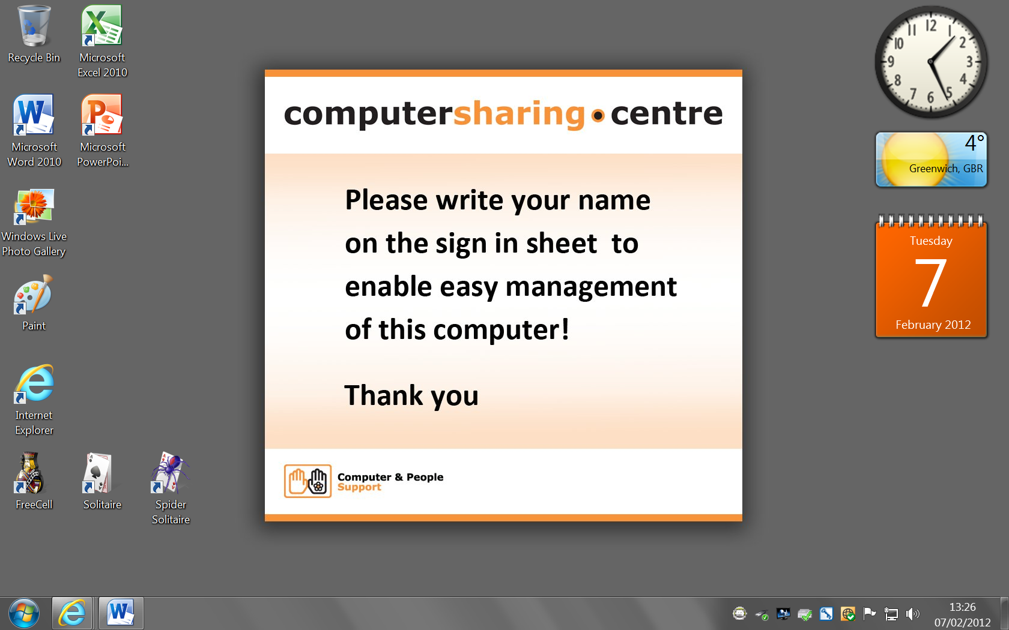
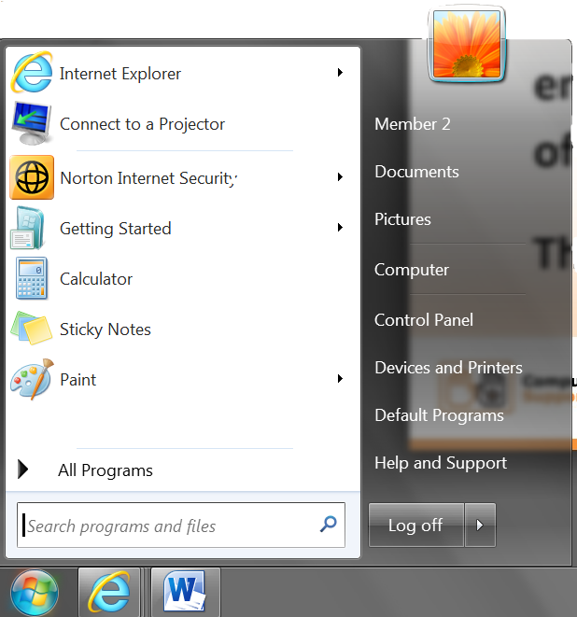
Above is the ‘Desktop” which will appear after about 20 seconds.
To Log off:
Each time you log off, the computer is restarted and all files that were created during your session are removed. This ensures your privacy.
- To log off, press the Windows key to open the Start Menu
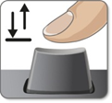
(or click on the round start button in the bottom left hand corner)
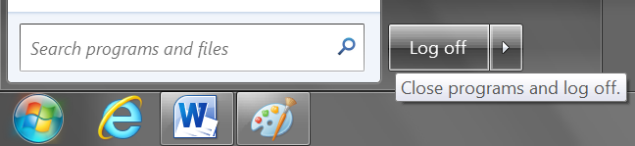
- Then click on or press the right Arrow key to highlight “Log off” as shown here, and press the Enter key

