**Learn how to play games on the computer at this presentation. Great for mental stimulation and getting more familiar with the computer!**

**Demonstrations:**

**How to play Solitaire, Pinball and more!**

**How to search using Google**

C:\Documents and Settings\Cherith\Local Settings\Temporary Internet Files\Content.IE5\4BUNHHB6\MCj04238400000[1].wmf

**Fun with games!**

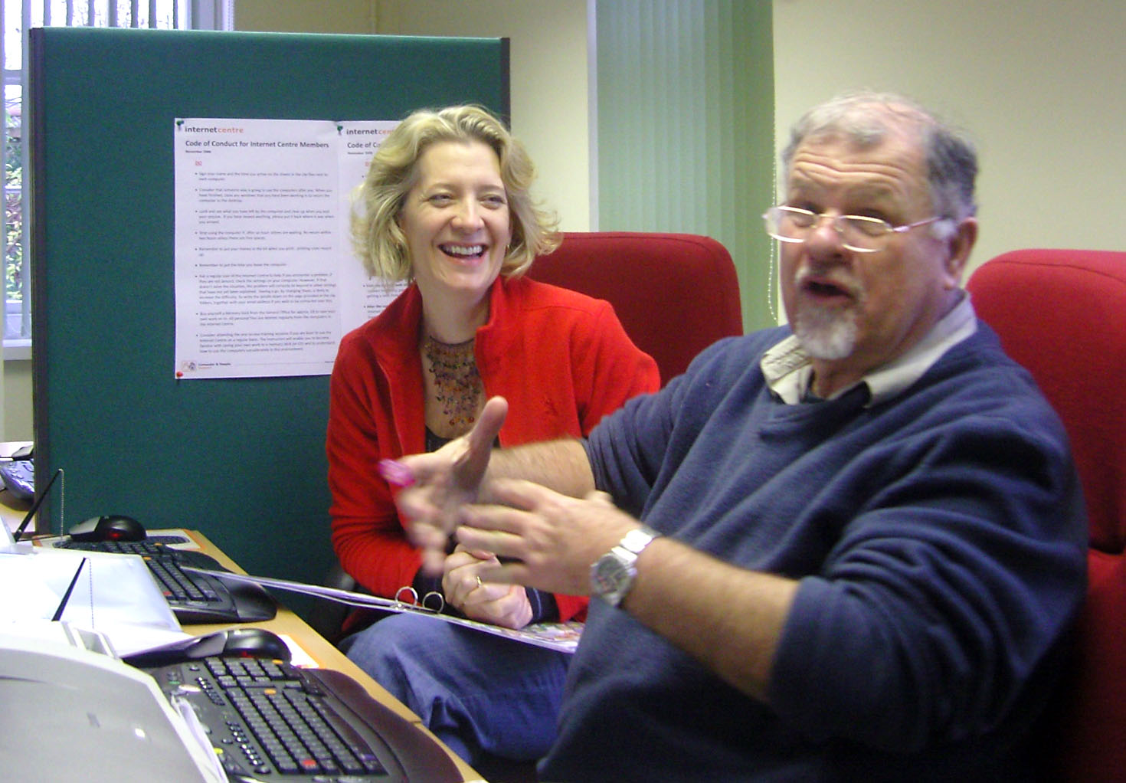

**Venue: ADD VENUE**

**All welcome!**

**Tea and Coffee will be served**

5L0412

© Computer Sharing Centre Ltd 2010 | www.computersharingcentre.com

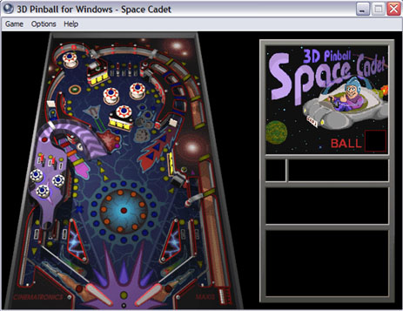





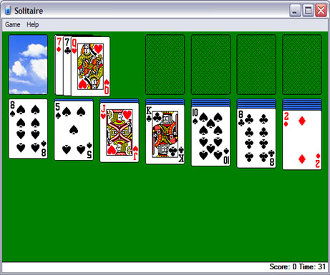

C:\Documents and Settings\Cherith\Local Settings\Temporary Internet Files\Content.IE5\1PCH3DRO\MCj04382530000[1].wmf

**Fun with Games and Google!**

**Date:** **ADD DATE**

**Time:** **ADD TIME**