

**Advanced Email:**

**Forward email, set up group email**

**Organise your emails**

**Open attachments and save to your memory stick**

**Add attachments to new emails**

**Advanced Google:**

**Learn how to get more from Google**

**Take home the very useful “Google Search Tips” sheet**



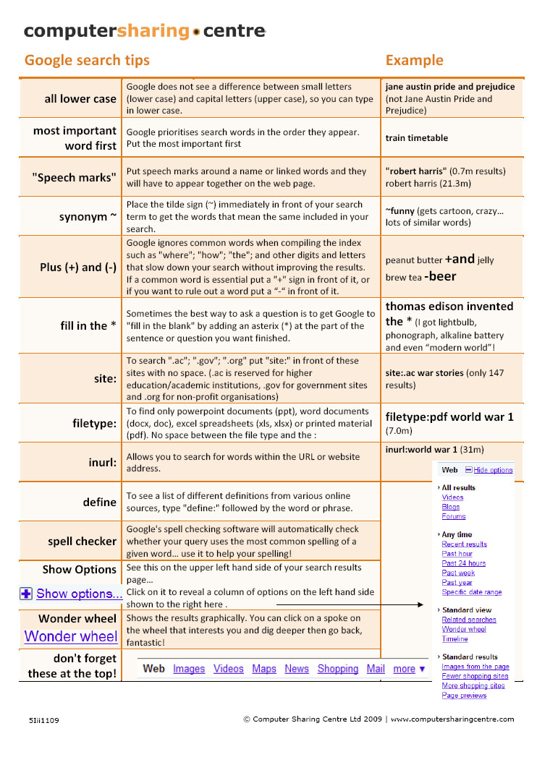



**Advanced Email & Google presentation**



**Learn more about Email & Google!**

**Date:** **ADD DATE**

**Time:** **ADD TIME**

**Venue: ADD VENUE**

**All welcome!**

**Tea, coffee and biscuits**

**will be served**

5N0412

© Computer Sharing Centre Ltd 2012 | www.computersharingcentre.com

