

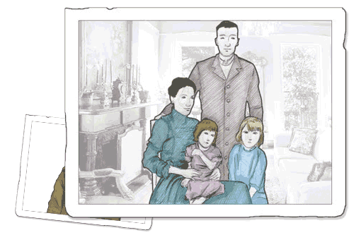





C:\Users\Liquid Jigsaw\AppData\Local\Microsoft\Windows\Temporary Internet Files\Content.IE5\3RUX7D21\MCPE02634_0000[1].wmf

**Venue: ADD VENUE**

**Tea and coffee will be served!**

**All are welcome!**

Since the 1990’s, archived records have been put on the internet so that they can be searched by people with a computer, anywhere in the world.

Genealogy has become extremely popular.

By creating a simple “personal archive” with the help of the Instructors at the Computer Sharing Centre, we can help generations to remember   
us as we would wish to be remembered.

**Genealogy presentation**

**Use the computer to research your ancestors!**

**Date:** **ADD DATE**

**Time:** **ADD TIME**

5P0412

© Computer Sharing Centre Ltd 2012 | www.computersharingcentre.com

