C:\Users\Liquid Jigsaw\AppData\Local\Microsoft\Windows\Temporary Internet Files\Content.IE5\Z3XX603T\MC900014785[1].wmf

**Tea and coffee will be served!**

**All are welcome!**

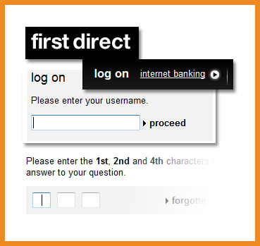

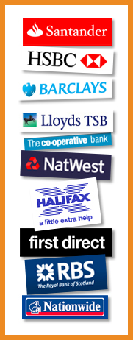





**Find out how easy it is to check your balance and pay your bills online**

**Millions of us are doing our banking on the internet. But how safe is it? What exactly are the risks?**

**How do the the Banks protect your money when you bank online?**

**See how secure it is – especially at   
the Computer Sharing   
Centre.**

**Online banking**

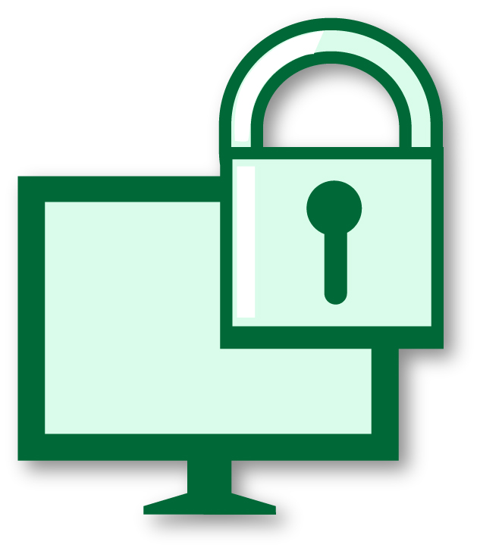

**Online banking, how does it work and is it secure?**

**Date:** **ADD DATE**

**Time:** **ADD TIME**

**Venue: ADD VENUE**

**Learn more at our presentation:**

5S0412

© Computer Sharing Centre Ltd 2012 | www.computersharingcentre.com

