

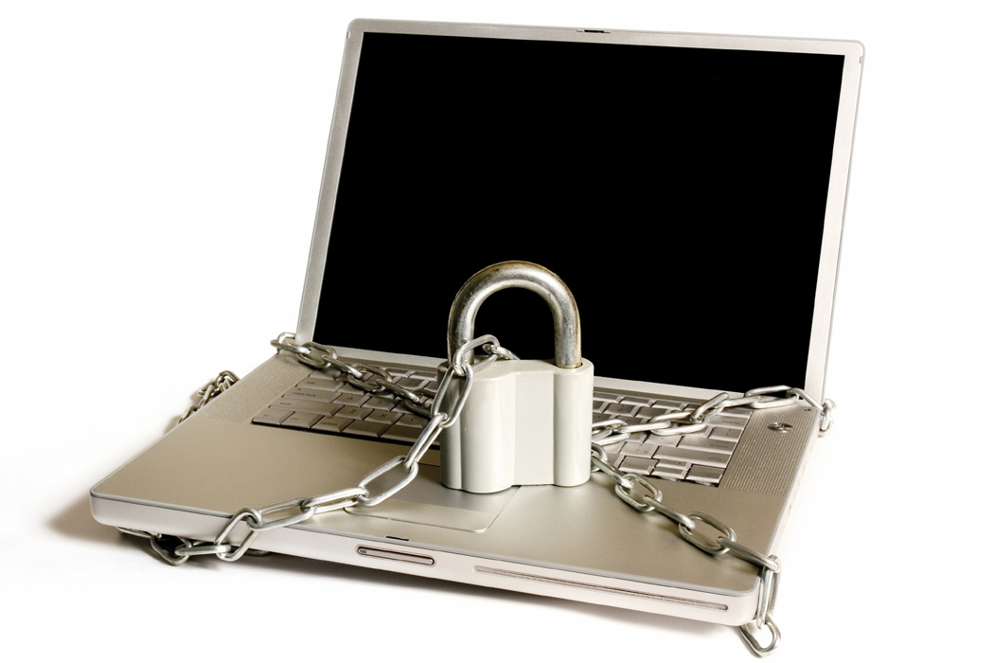

C:\Users\Tania\AppData\Local\Microsoft\Windows\Temporary Internet Files\Content.IE5\2J1TH0YO\MC900439967[1].wmf

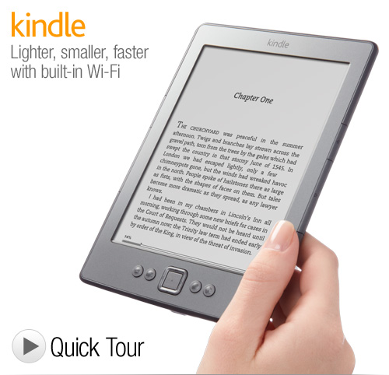

**The Amazon Kindle:**

**See one in action! –** Did you know that residents and staff can connect their kindle to the internet thanks to the Computer Sharing Centre?   
Many classic books are free to download   
and with a kindle you can read large print

**Introduction to the Kindle and how to be safe online!**

**Date:** **Thursday 1 December**

**Time:** **11am – 12 midday**

**No charge!  
no charge**

**Security:**

Find out about how to choose a   
**good password**

See examples of   
**email scams!**

Learn how **safe** the   
computers at the   
Computer Sharing   
Centre are – so you can confidently pay for tickets and shop online

**Venue: Social Club Lounge**

**Tea and coffee will be served!**

**All are welcome!**

**Amazon Kindle and online security**



5T0812

© Computer Sharing Centre Ltd 2012 | www.computersharingcentre.com

