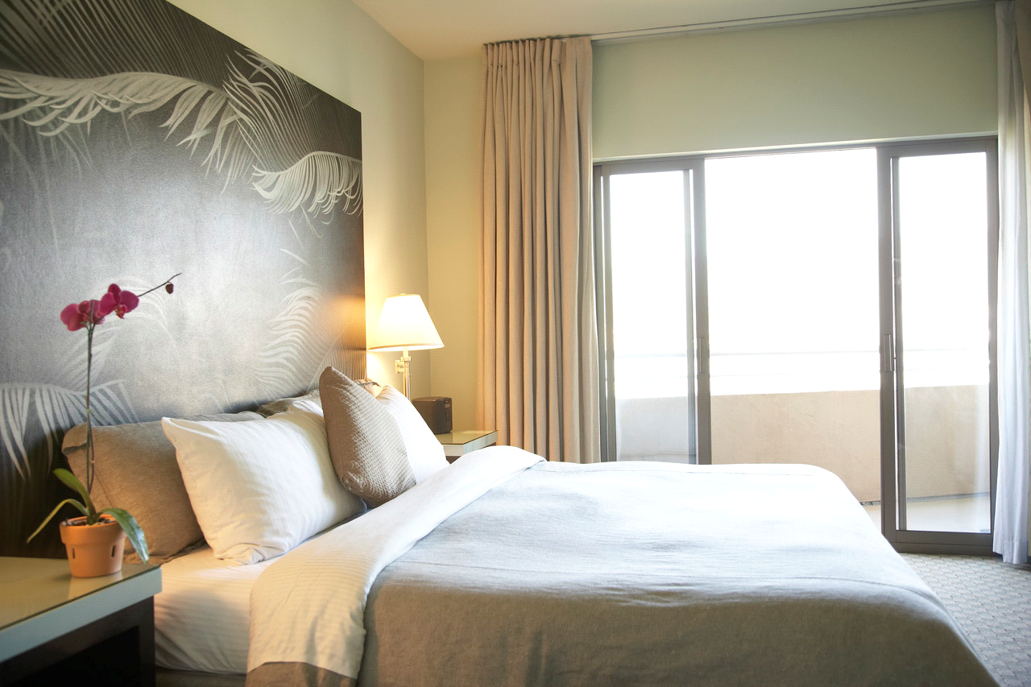

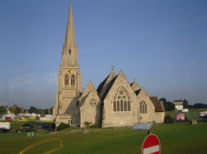

**Planning a Weekend Break in Blackheath presentation**



**If you know where the best local places are to stay, you can tell your friends and relatives.** **Detailed hand outs will be given!**

**Venue: The Social Club**

**Coffee and biscuits  
 will be served!**

**All are welcome!**

**Come learn how to find out what the best hotels are in Blackheath/Greenwich and how much they charge - using the internet**

**Compare the best hotels –   
using the internet!**

**Presentation by Cherith Hateley,**

**John Aspey & Carolyn Watkins**

**Date:** **Wednesday 13 February Time:** **11am – 12 midday**



**See how hotel comparison websites work so you can search for hotels *in other locations*!**

**Find out details of reviews, hotel discounts for early booking, and what you get for your money**

5W0213

© Computer Sharing Centre Ltd 2013 | www.computersharingcentre.com

