Downloading and using keyboard graphics in Word documents

- Open Internet Explorer and go to the Instructors area of the Courses website or use this link: www.computersharingcentre.com/courses/instructors

- Go to the “Keyboard keys to download” section and click on the link or the image of keys:

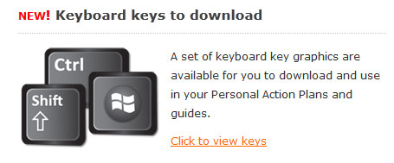

Or click on this link: www.computersharingcentre.com/courses/instructors/keys

- On the “Keyboard keys” page, click on the key image you would like to download. You will need to enter the Courses site password to access these graphics. A new page will open showing a 400dpi version of your chosen key.
Please note: It will look large on the web page as it is a high resolution file but it will appear much smaller once in Word!

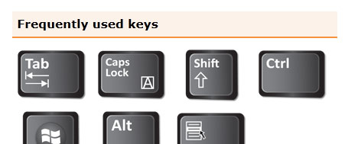
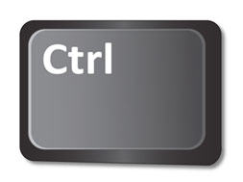

- Right click on the key image, select “Save picture as…”and browse on your computer to find a suitable place to save the JPEG file.

- Open your Word document – this may be a Personal Action Plan or guide you are creating for a student.

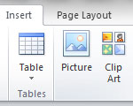
- Place your cursor where you would like your key graphic to appear. Click on the “Insert” tab at the top of Word and click on the “Picture” icon.

- Browse to find the graphic that you downloaded and click “Insert”.

It will look like this: 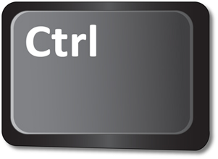
- Double click on the graphic to open the “Picture Tools”. Click on the “Wrap Text” icon and select “Tight” to wrap the text around the image. You can now click and drag the graphic to feely move it into the correct position.

- Double click on the graphic again; click on “Wrap Text” and this time select “More Layout Options”. A box will open showing the “Text Wrapping” tab - go to the section called “Distance from text”. Here you can adjust how close the text appears to the sides of the key graphic.

- You will need the text to be quite close to the graphic, so try typing 0.1 cm or 0.2 cm in both the “Left” and “Right” boxes. Then click “OK”.

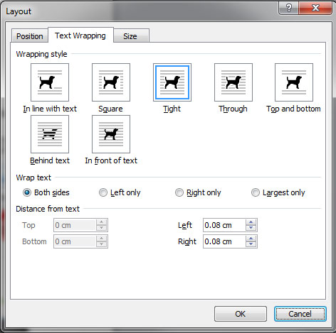

You can either click and drag your graphic to position it or click to select it and use the Arrow keys to move it into the correct place.

Here is an example of what the end result should look like:

To copy, press +

