C:\Users\Tania\AppData\Local\Microsoft\Windows\Temporary Internet Files\Content.IE5\35GIYN9Y\MC900435731[1].wmf

**All welcome!**

**Tea and Coffee will be served**





**Come and watch our Instructors give you brief and fun introductions to the things you may have got tired of hearing about –**

**Who knows, you may even want to give one of them a try?**

[](http://ohinternet.com/File:Wikipedia-logo.png)



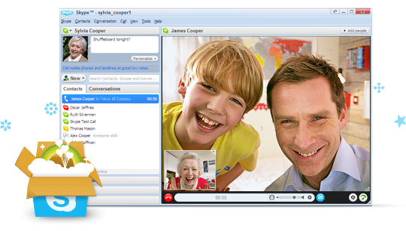

[](http://www.facebook.com/photo.php?fbid=357452906653&set=a.473083416653.283943.316001081653&type=1)

[](http://nedcolville.files.wordpress.com/2011/08/bbc-iplayer-logo.jpg)

**Introducing you to what lots of people enjoy doing on the internet in 2012!**

**Date:** **ADD DATE**

**Time:** **ADD TIME**

**Venue: ADD VENUE**

[](http://blogs.independent.co.uk/wp-content/uploads/2012/08/twitter-logo.png)

**An introduction: What on earth is that?**

5I0912

© Computer Sharing Centre Ltd 2012 | www.computersharingcentre.com

