**Venue: ADD VENUE**

**All welcome!**

**Tea and Coffee will be served**

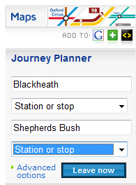

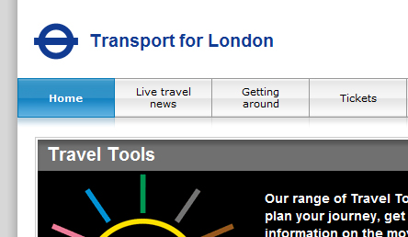

**Planning to travel across**

**London or further afield?**

**At this seminar learn how**

**to plan your journey using**

**the Computer Sharing**

**Centre’s Topsites web page**

**as your starting point.**

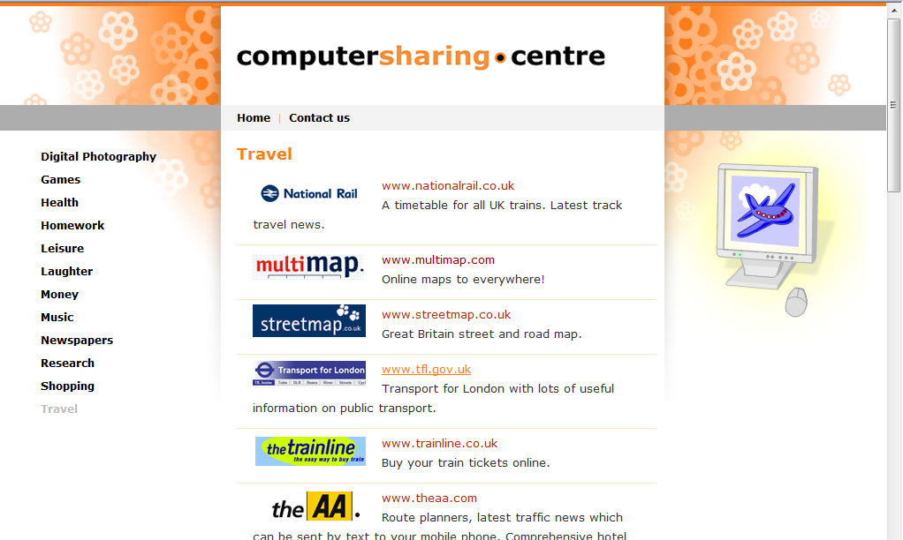

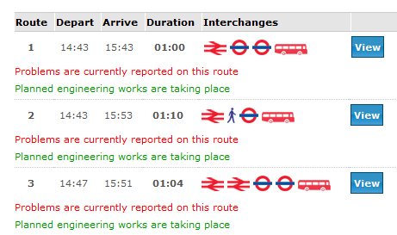

**Plan your journey**

**with our help!**

**Date:** **ADD DATE**

**Time:** **ADD TIME**

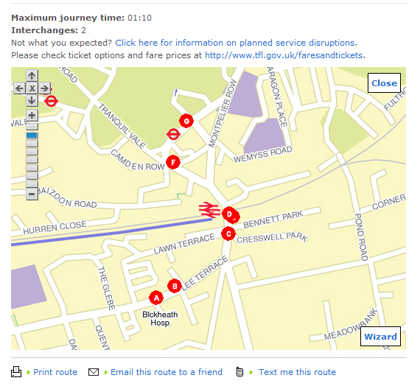

**Planning your journey!**

5O0412

© Computer Sharing Centre Ltd 2012 | www.computersharingcentre.com

