**All welcome!**

**Tea and coffee**

**will be served**





**Find out:**

**How easy it is to watch a TV program or listen to a radio broadcast that you have missed**

**How you can get your own ‘BBC iD’ which allows you to set your favourite programs and categories (very useful)**

**Sit back and relax!**

**We will take a look at the best and most popular programs of the past week**

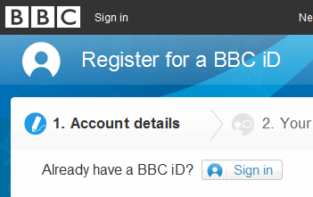

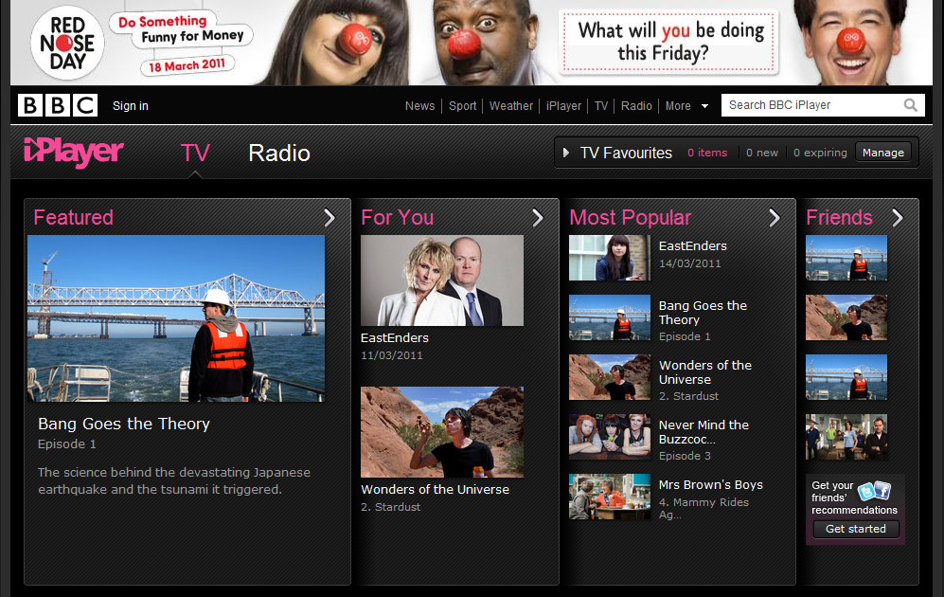

logo.gif

**Never miss a TV program again!**

**Date:** **Wednesday 23rd March 2011**

**Time:** **11am – 12pm**

**Venue: Social Club Lounge**

**Introduction to BBC iPlayer!**

5Q0812

© Computer Sharing Centre Ltd 2012 | www.computersharingcentre.com

