**Shopping on Amazon.co.uk**



**Watch as we buy books, CDs and DVDs on the largest online shop - "Amazon.co.uk".**

**Items will be paid for using ADD NAME's credit card and delivered to ADD VENUE - normally within 24 hours.**

**(Residents are expected to pay her back!)**

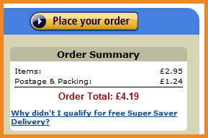

**Venue: ADD VENUE**

**Tea and coffee will be served!**

**All are welcome!**



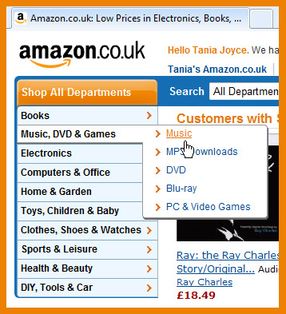



**Shopping online!**

**Date:** **ADD DATE**

**Time:** **ADD TIME**

5R0412

© Computer Sharing Centre Ltd 2012 | www.computersharingcentre.com

