**Christmas e-card presentation**



C:\Users\Cherith\AppData\Local\Microsoft\Windows\Temporary Internet Files\Content.IE5\2TSZYT46\MC900199284[1].wmf

C:\Users\Tania\AppData\Local\Microsoft\Windows\Temporary Internet Files\Content.IE5\RJNDBF5S\MC900361924[1].wmf

**Venue: The Social Club**

**Cava will be served!**

**All are welcome!**

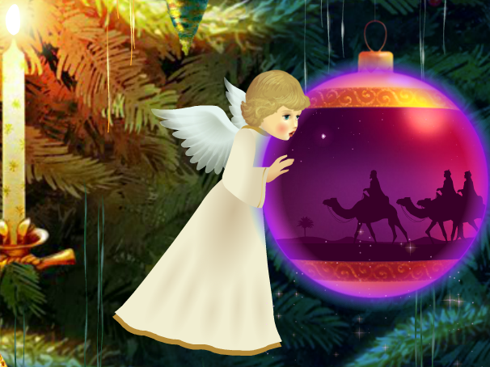

**The e-card experience**

**with Jacquie Lawson**

**How to create a**

**Christmas letter**

**in Word**

**How to print   
off some   
festive online   
recipes**

C:\Users\Tania\AppData\Local\Microsoft\Windows\Temporary Internet Files\Content.IE5\2J1TH0YO\MC900439967[1].wmf



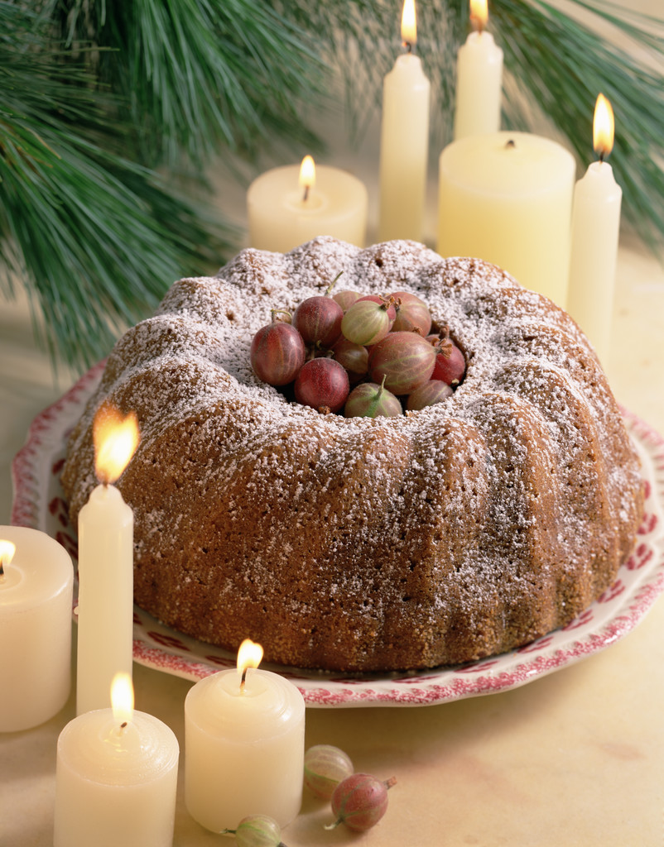

**Date:** **Wednesday 12 December Time:** **11am – 12 midday**

**Find out more about using the internet at Christmas!**

**with Cherith Hateley, John Aspey   
& Carolyn Watkins**



5V1212

© Computer Sharing Centre Ltd 2012 | www.computersharingcentre.com

