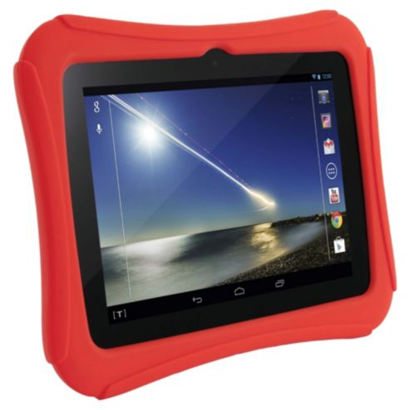

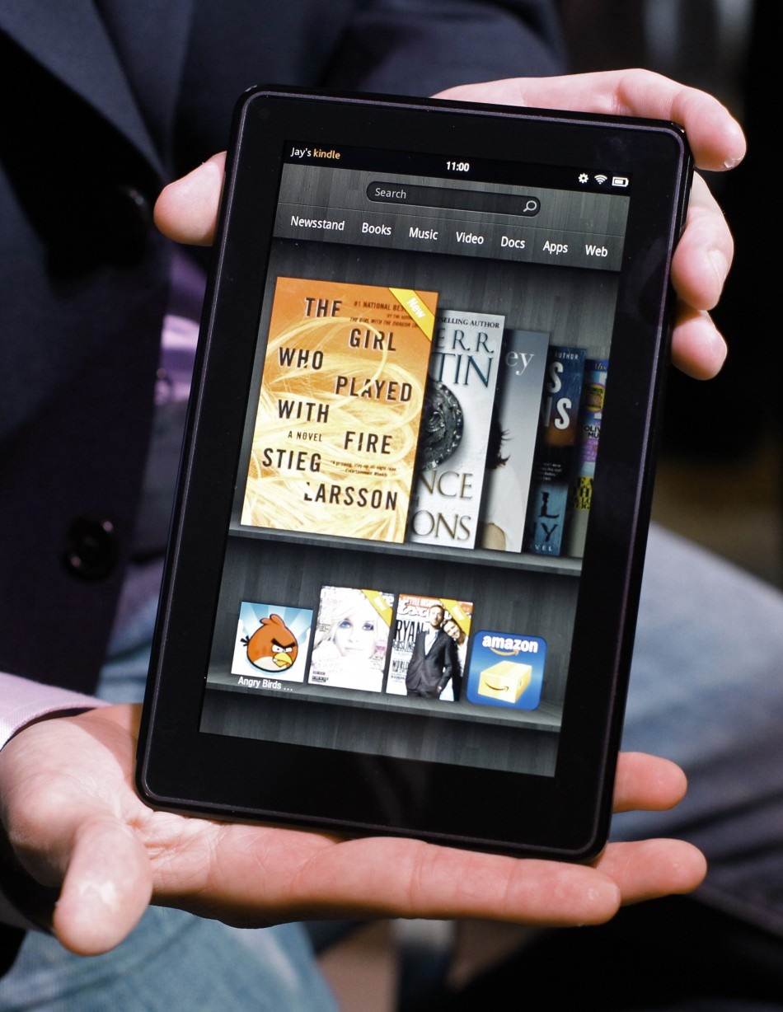

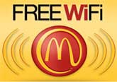

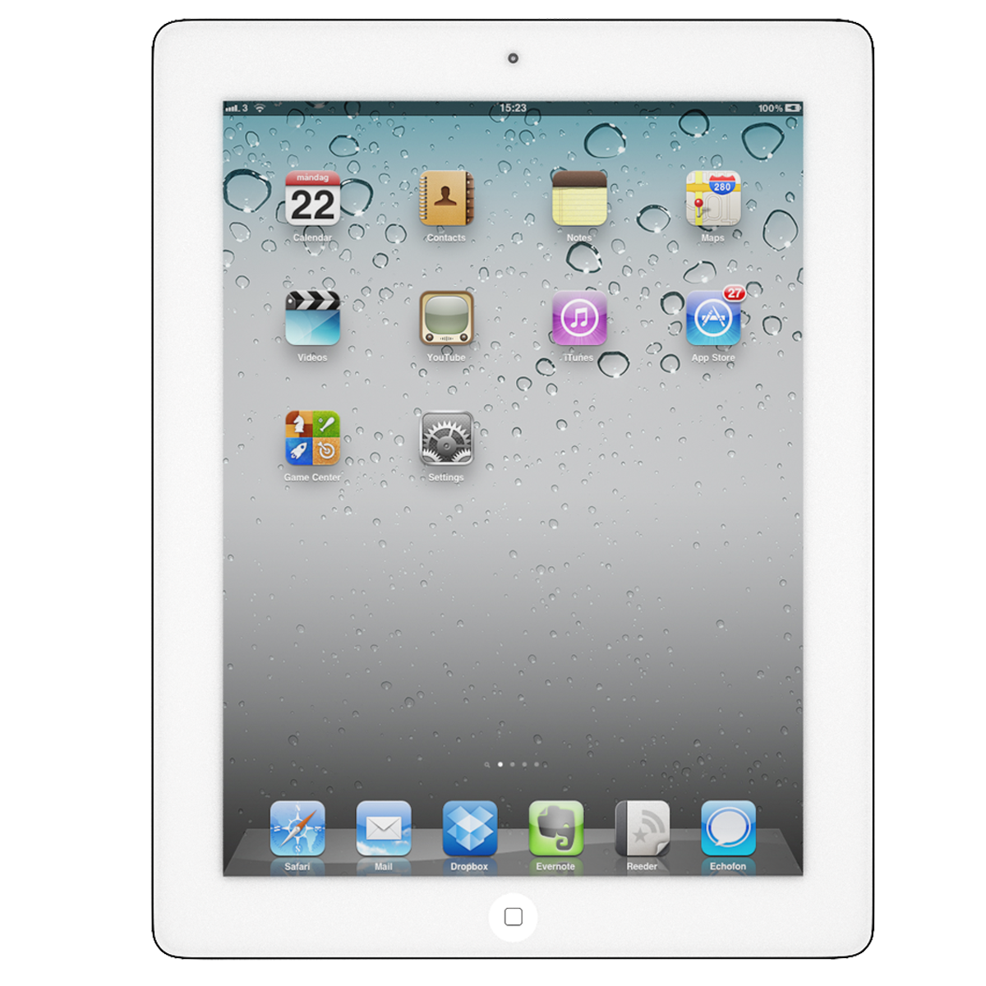

**What *is* WiFi?**

***What* *do* people use their iPads, Hudls or Kindle Fires for?**

**Date:** **5th March 2014**

**Time:** **11am to 12 midday**

**Venue: Morden Hall**

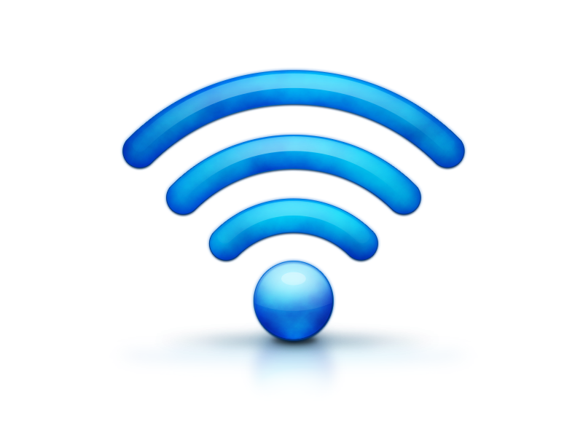



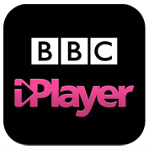



**Come and watch your Instructors demonstrate an iPad, a Tesco Hudl and a Kindle Fire – then explain how it connects to the internet with ‘wifi’**

**Who knows, you may decide you want one!**

**All welcome!**

**Tea and Coffee will be served**

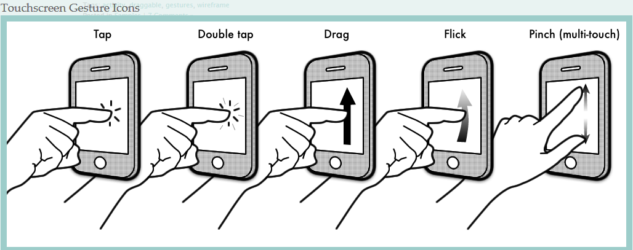

**Introduction to wifi and tablets**

5Y0214

© Computer Sharing Centre Ltd 2014 | www.computersharingcentre.com

