Rules for the Centre
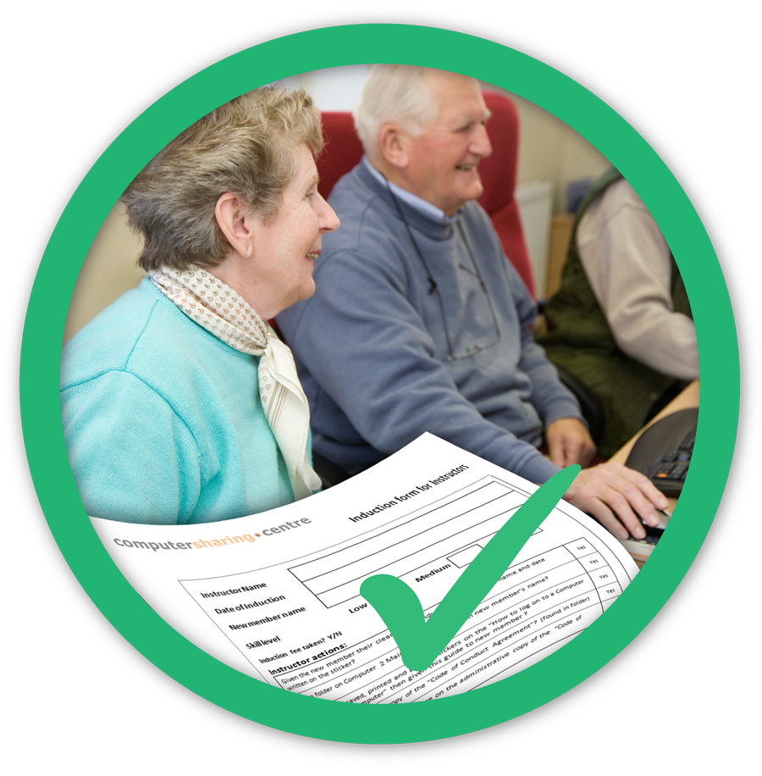
- Only members, or visitors with temporary membership, can use these computers

- Always sign in and out on the sheets provided

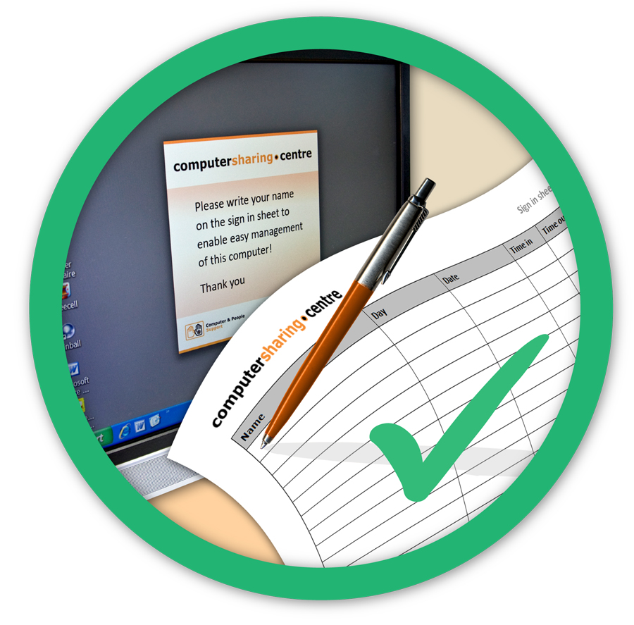
- Be considerate to other members – tidy up after yourself and stop after an hour if another member is waiting

- When using a computer during another member’s one-to-one lesson, please remember that the lessons can be noisy but you should not disturb them

- Wear the headsets when required

- No eating or drinking – drinks should be left outside the Centre on the table provided

Thank you

